Title of your research article (font garamond, bold, size 18, justified, limited to 15 words)

Abstract
Keywords:

Keyword 1
Keyword 2
Keyword 3
Keyword 4
Keyword 5

Introduction: The abstract of original articles should be structured. The word count must be a maximum of 250 words. Abstracts of manuscripts of other categories such as review article could be unstructured. Avoid symbols and abbreviations in the abstract. Methods: Manuscript text must be submitted using the template in Microsoft Word (in .doc or.docx only). Review articles and case reports can be submitted by author. Introduction, relevant section headings, conclusion and up to 50 references. The total number of words including references, table and figure captions should be no more than 5000 words and use English (UK). Results: Donec condimentum luctus metus vel condimentum. Suspendisse aliquet, tellus sed dignissim maximus, lacus dolor gravida ipsum, vel semper nulla est non sapien. Suspendisse varius ante a massa efficitur elementum. Pellentesque faucibus ullamcorper euismod. Phasellus egestas mattis justo eu dapibus. Sed lobortis, eros id iaculis gravida, mauris mauris consequat libero, eget imperdiet ante sem id magna. Cras sagittis sapien eu lacus tempus posuere. Nullam rhoncus pellentesque nisi ut imperdiet. Pellentesque habitant morbi tristique senectus et netus et malesuada fames ac turpis egestas. Donec eros sem, auctor ac tempus et, congue in ligula. Suspendisse aliquet, tellus sed dignissim maximus, lacus dolor gravida ipsum, vel semper nulla est non sapien. Suspendisse varius ante a massa efficitur elementum. Pellentesque faucibus ullamcorper euismod. Conclusion: Sed at viverra nunc, at aliquet ante. Aenean aliquet, eros eget malesuada tristique, neque magna gravida purus, non ornare.

Introduction
The introductory section plays a crucial role in contextualising the study and underscoring its significance. State briefly the purpose, and rationale for the study or observation. Avoid a review of the subject by confining to only relevant information and references. Do not include data or conclusions from the work being cited. Citations are written according to APA 7th style. Kindly refer to the example of references in this template. Examples of in-text citations (Almanasef, 2021; Chang et al., 2020; Chung et al., 2021; Devraj et al., 2019; Liu et al., 2022; Martí-García et al., 2023; Morse, 2000; Zaini et al., 2018).

Materials and methods

Materials
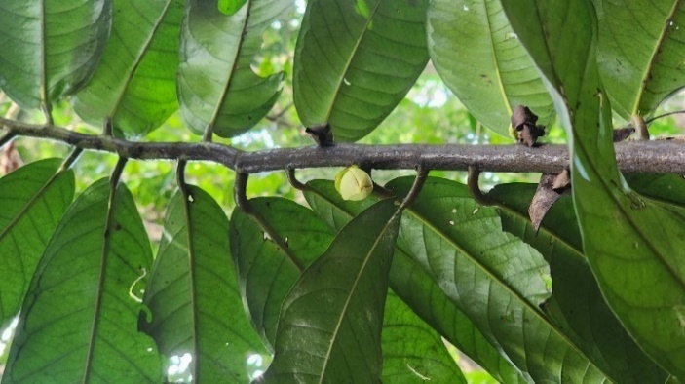
A precise description of the selection of your observational or experimental subjects (patients or laboratory animals, including controls) must be presented. A comprehensive depiction of the Materials and Methods section is essential to enable reproducibility and the advancement of the findings presented in this publication. State the methods, apparatus (including manufacturer’s name and address in parenthesis), and procedures in sufficient detail to allow others to reproduce the method. In the case(s) of established methods or techniques, give references.

Method

Subheading 2
References for methods that have been published but are not well-known must also be provided. For new or substantially adapted methods, describe and give reasons for using them and critically evaluate their limitations. All chemicals and drugs used must be identified correctly, including their generic names, the name of the manufacturer, city and country in parenthesis. The dosage should be mentioned accurately including the route of administration. The International System of Units (SI) should be used, and Footnotes avoided. For studies involving interventions with animals or humans, as well as other investigations requiring ethical endorsement, it is essential to provide authority that provide the approval and corresponding ethical approval code.
Table 1: Caption for Table 1
Title 1 | Title 2
Item 1 | Data 1
Item 2 | Data 2
Item 3 | Data 3
Item 4 | Data 4

Results and discussion
Provide a concise and precise description of the experimental results, their interpretation as well as the experimental conclusions that can be drawn. The Results section should include all primary and secondary outcome measures analysed. The section may be divided into subsections, each with a concise subheading. Tables and figures central to the study should be included in the main paper. The Results section should be written in past tense. This section may be divided by subheadings. It should provide a concise and precise description of the experimental results, their interpretation, as well as the experimental conclusions that can be drawn.
Fig. 1: The leaves of Goniothalamus sp. Taken from Taher et al. (2024) with permission.

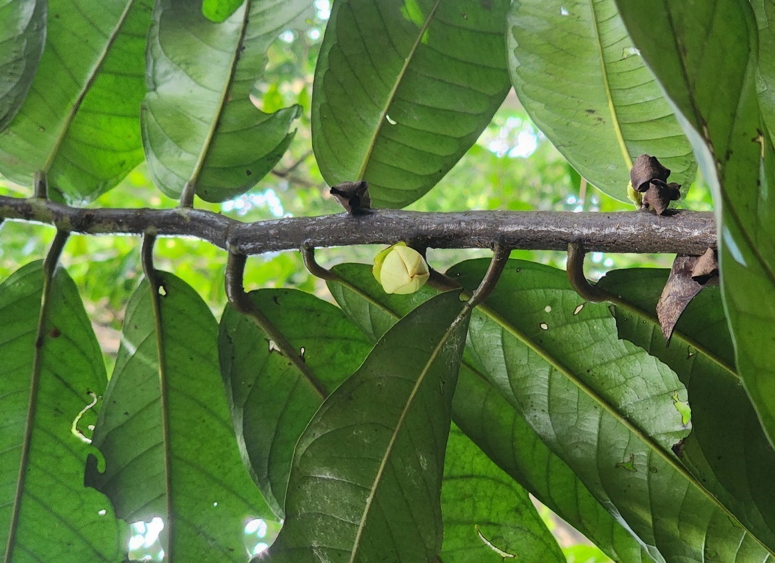
.
Fig. 2: The leaves of Goniothalamus sp. Taken from Taher et al. (2024) with permission
Table 2: Caption for Table 2
Title 1 | Title 2 | Title 3 | Title 4 | Title 5
Item 1 | Data 1 | Data 1 | Data 1 | Data 1
Item 2 | Data 2 | Data 2 | Data 2 | Data 2
Item 3 | Data 3 | Data 3 | Data 3 | Data 3
Item 4 | Data 4 | Data 4 | Data 4 | Data 4
Item 5 | Data 5 | Data 4 | Data 4 | Data 4
Item 6 | Data 6 | Data 6 | Data 6 | Data 6
Item 7 | Data 7 | Data 7 | Data 7 | Data 7
Item 8 | Data 8 | Data 8 | Data 8 | Data 8
Item 9 | Data 9 | Data 9 | Data 9 | Data 9
Item 10 | Data 10 | Data 10 | Data 10 | Data 10
Item 11 | Data 11 | Data 11 | Data 11 | Data 11
Item 12 | Data 12 | Data 12 | Data 12 | Data 12

Tables and Figures
Tables and figures (i.e. illustrations/ diagrammes/ photographs) are placed within the main text at the appropriate points NOT at the end. Captions along with legends must accompany the appropriate tables and figures. Tables should be in .docx or .doc format, NOT .jpg or .png. Figures should be in either .jpg or .png format, displaying a high level of image quality. Both tables and figures should be cited in the main text as Fig. 1, Fig. 2, Table 1, Table 2, and etc.
Permission is required for figures irrespective of authorship or publisher, except for documents in the public domain. Human subjects must not be identifiable in photographs. If this is unavoidable, pictures of patients must be accompanied by written permission from the patients or legal guardians granting permission to use the photographs.
The main text of the document accommodates a maximum of five tables and/or figures. Any additional tables and figures beyond this limit should be included as appendices.

Abbreviations, Symbols and Equations
Use only standard abbreviations. Avoid the use of abbreviations and symbols in the title and abstract. Use the full term first and subsequently the abbreviation. Use the full term if it is a standard unit of measurement. In general, symbols and abbreviations should be those used by British Chemical and Physiological Abstracts. Weights, volumes, etc. should be in metric units.
Numbers and symbols should be clear and of sufficient size that when reduced for publication each item will still be legible. Poor quality illustrations will not be accepted.
This is an equation:
a = 1 | (1)
Elaborate on the new and important findings of the study. Do not repeat in detail data or other information already given in the Introduction or the Results sections. Compare and discuss with previous works (citing references). Discuss the implications of the findings, their broader significance and their limitations. Avoid claiming priority and alluding to work that has not been completed.
State new hypotheses when warranted. Discuss your finding about future research. Recommendations, when appropriate, must be given at the end of this section followed by a concluding paragraph.

Conclusion
State the main conclusions drawn from the study. Link the conclusions with the goals of the study.

Authors contributions
The authors must provide authors contribution statements which are short descriptions of the specific roles and tasks that each author performed in a research project. E.g.: “Conceptualization, X.X. and Y.Y.; methodology, X.X.; software, X.X.; validation, X.X., Y.Y. and Z.Z.; formal analysis, X.X.; investigation, X.X.; resources, X.X.; data curation, X.X.; writing—original draft preparation, X.X.; writing—review and editing, X.X.; visualization, X.X.; supervision, X.X.; project administration, X.X.; funding acquisition, Y.Y. All authors have read and agreed to the published version of the manuscript.”

Acknowledgements
Acknowledgments of people, grants, funds, etc. should be placed in a separate section before the reference list. The names of funding organisations should be written in full.

Ethical approval statement (if applicable)
The author should add the Ethical Approval Statement and approval number. The author might choose to exclude this statement if the study did not require ethical approval. E.g.: “The animal study protocol was approved by the Ethics Committee of NAME OF INSTITUTE (protocol code XXX and date of approval).”

Informed consent statement (If applicable)
Any research article describing a study involving humans should contain this statement. Please add “Informed consent was obtained from all subjects involved in the study.” OR “Patient consent was waived due to REASON (please provide a detailed justification).”

Conflict of interest
The authors must declare any conflicts of interest as a statement in the text. Authors having no conflict of interests should make an appropriate declaration. All funding sources of the research must be written in acknowledgements.

Declaration of generative AI and AI-assisted technologies in the writing process
During the preparation of this work the author should declare in the case where AI (e.g. ChatGPT, Gemini and others) are used in order to improve readability and language. After using this tool/service, the author should review and edit the content as needed and take full responsibility for the content of the publication.

References (APA 7th style)

Almanasef, M. (2021). Mental health literacy and help-seeking behaviours among undergraduate pharmacy students in abha, saudi arabia. Risk Management and Healthcare Policy, 14, 1281–1286. https://doi.org/10.2147/RMHP.S289211

Chang, C. M., Li, Y., Or, L. L., Pikkarainen, M., Pölkki, T., Wang, W., Lau, S. T., & He, H. G. (2020). A Qualitative Study Exploring Singaporean Parents’ Perceptions on PreParing their Child for Surgery. Journal of Pediatric Nursing, 54(2020), e69–e77. https://doi.org/10.1016/j.pedn.2020.05.004

Chung, A., Vieira, D., Donley, T., Tan, N., Jean-Louis, G., Kiely Gouley, K., & Seixas, A. (2021). Adolescent Peer Influence on Eating Behaviors via Social Media: Scoping Review. Journal of Medical Internet Research, 23(6), e19697. https://doi.org/10.2196/19697

Devraj, R., Gupchup, G. V, & Henson, D. (2019). Mental Health Literacy of Pharmacy Students Compared to Nursing and Medical Students. INNOVATIONS in Pharmacy, 10(4), 2. https://doi.org/10.24926/iip.v10i4.2091

Liu, K. S. N., Chen, J. Y., Sun, K.-S., Tsang, J. P. Y., Ip, P., & Lam, C. L. K. (2022). Adolescent Knowledge, Attitudes and Practices of Healthy Eating: Findings of Qualitative Interviews among Hong Kong Families. In Nutrients (Vol. 14, Issue 14). https://doi.org/10.3390/nu14142857

Martí-García, C., Fernández-Férez, A., Fernández-Sola, C., Pérez-Rodríguez, R., Esteban-Burgos, A. A., Hernández-Padilla, J. M., & Granero-Molina, J. (2023). Patients’ experiences and perceptions of dignity in end-of-life care in emergency departments: A qualitative study. Journal of Advanced Nursing, 79(1), 269–280. https://doi.org/10.1111/jan.15432

Zaini, S., Bharathy, H. A. M., Sulaiman, A. H., Gill, J. S., Hui, K. O., Huri, H. Z., Shamsudin, S. H., & Guan, N. C. (2018). Development of a strategic tool for shared decision-making in the use of antidepressants among patients with major depressive disorder: A focus group study. International Journal of Environmental Research and Public Health, 15(7). https://doi.org/10.3390/ijerph15071402

Appendix A (if applicable)
The appendix is an optional section that can contain details and data supplemental to the main text—for example, explanations of experimental details that would disrupt the flow of the main text but nonetheless remain crucial to understanding and reproducing the research shown; figures of replicates for experiments of which representative data is shown in the main text can be added here if brief, or as Supplementary data. Mathematical proofs of results not central to the paper can be added as an appendix.
All appendix sections must be cited in the main text. In the appendices, Figures, Tables, etc. should be labeled starting with “A”—e.g., Figure A1, Table A1, etc.

