INSERT THE TITLE OF YOUR MANUSCRIPT HERE

AUTHOR 1, AUTHOR 2*, AUTHOR 3, AUTHOR 4, AUTHOR 5
International Institute for Halal Research and Training (INHART), International Islamic University Malaysia, Jalan Gombak, 53100 Kuala Lumpur, Malaysia.
*Corresponding author: emailauthor2@institute.edu.my
(Received: Date^{th.} Mon. 201X, Accepted: Date^{th} Mon.. 201X; Published on-line: Date^{th} Mon.. 201X)

ABSTRACT: (Background statement) ……………………………………………………………... (Narrowing statement)………. ……………………………………………………………………………. (Elaboration of narrowing statement).…………………………………………………………………………………………………. (Aims) ……………………………………………………………………………………………………… (Method) …………………………………………………………………………………………………… (Results) …………………………………………………………………………………………………... (Conclusion) ……………………………………………………………………………………………….

KEYWORDS: xxxxx; xxxxx; xxxxx; xxxxx; xxxxxx

- INTRODUCTION

[SAMPLE TEXT] xxxxxxxxxxxx

- MATERIALS AND METHODS
2.1 Subtopic One
2.1.1 Sub Subtopic One

XXXXX
2.2 Subtopic Two
2.2.1 Sub Subtopic Two
XXXXX

2.3 Subtopic Three
XXXXXX.

2.4 Subtopic Four
XXXXXX

- RESULTS AND DISCUSSION
3.1 Subtopic One
XXXXX

3.2 Subtopic Two
XXXXX

3.3 Subtopic Three
XXXXX

3.4 Subtopic Four
XXXXX

Example of citation in the text body
Manuscripts should adhere to the Publication Manual of the American Psychological Association, latest edition; for journal (Asri et al., 2022), for book section/chapter (Sani et al., 2023) and book (Nizar et al., 2023). For further information on citation and reference style, please visit http://www.apastyle.org/.
Example for Table
Table 1: XXX
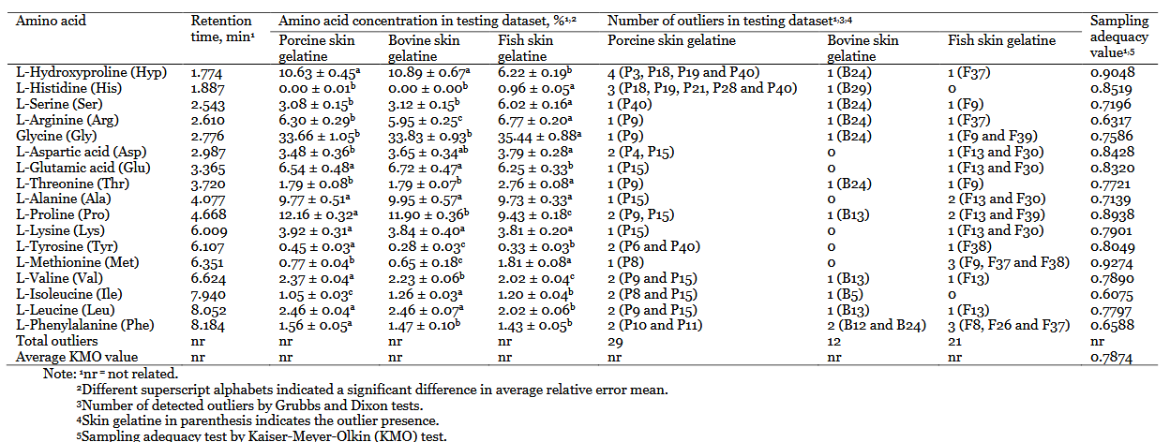

Example for the figure
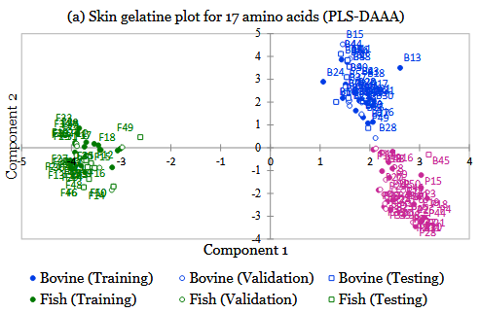
Figure 1: XXX

- CONCLUSION
XXXXX

ACKNOWLEDGEMENTS
{SAMPLE}This work was funded by research grant granted by ….. research grant no. #######.
{SAMPLE} The authors like to express their thanks to Ministry of Education (MOE) for granting a Fundamental Research Grant Scheme (FRGS), project no. FRGS-##-###-### for the financial support. Special thanks as well to the Department of Biotechnology Engineering, Faculty of Engineering, International Islamic University Malaysia for providing the equipment, chemicals and instruments for this research.
CONFLICT OF INTEREST
{SAMPLE} The authors declare no competing interests.
AI DECLARATION
{SAMPLE} Artificial Intelligence (AI) tools, including ChatGPT (OpenAI, San Francisco, CA), were used to assist in language editing, improving sentence structure, and clarifying grammar during the manuscript preparation stage. The authors reviewed, verified, and take full responsibility for the accuracy and integrity of the content. No AI tools were used for data analysis, interpretation of results, or drawing scientific conclusions.
OPEN ACCESS
The article will be published under the Creative Commons Attribution-NonCommercial 4.0 International License (CC BY-NC 4.0), allowing others to share and adapt the work for non-commercial purposes, with appropriate credit.
AUTHOR CONTRIBUTION
{SAMPLE} Author 1: project administration, conceptualization, methodology, formal analysis, investigation, data curation, writing original draft preparation, writing, reviewing and editing. Author 2: writing, reviewing and editing. Author 3: writing, reviewing and editing. Author 4: writing, reviewing and editing. Author 5: writing, reviewing and editing.
REFERENCES
Asri, N. A. A. M., Sania, M. S. A., Othman, R., Nordin, N. F. H., & Desa, M. N. M. (2022). Antibacterial activities, chemical composition and efficacy of green extract Carica papaya peel on food model systems. Halalsphere, 2(2), 25–38.
Nizar, N. N. A., Abidin, S. A. S. Z., & Bujang, A. (2023). Innovation of food products in halal supply chain worldwide (N. N. A. Nizar, S. A. S. Z. Abidin, & A. Bujang (eds.)). Elsevier Inc.
Sani, M. S. A., Nordin, N. F. H., & Elgharbawy, A. A. M. (2023). Halal detection technologies: Analytical method approaches, validation and verification, and multivariate data analysis for halal authentication. In N. N. A. Nizar, S. A. S. Z. Abidin, & A. Bujang (Eds.), Innovation of Food Products in Halal Supply Chain Worldwide (pp. 253–271). Elsevier Inc.

