Submission Requirements Acknowledgement
You must read and acknowledge that you have completed all the requirements below before proceeding with submission.

No | Tick | Acknowledgement
1 |  | The submission has not been previously published and is not under consideration elsewhere, or the authors have disclosed any relevant publication/submission history in the Comments to the Editor.
2 |  | All required submission documents have been prepared using the designated templates, including:
 |  | Cover Letter
 |  | Manuscript
 |  | Authorship Declaration & Copyright Transfer Form
 |  | Cover Letter
3 |  | A cover letter addressed to the Editor is provided as a formal introduction to the manuscript submission.
4 |  | Potential reviewers may be suggested, or reviewers to be excluded may be indicated, if applicable.
5 |  | The cover letter is submitted in PDF format.
 |  | Manuscript
6 |  | The manuscript strictly follows the prescribed journal template.
7 |  | The sequence of authors is correct and matches the order recorded in the submission system.
8 |  | The corresponding author’s email address is provided on the author page.
9 |  | Full institutional addresses, including postcode, are included.
10 |  | Place an asterisk (*) next to the corresponding author’s name as indicated in the template.
11 |  | The manuscript file is submitted in Microsoft Word format.
 |  | Authorship Declaration & Copyright Transfer Form
12 |  | The form has been signed by all contributing authors.
13 |  | The completed form is uploaded at the time of manuscript submission.
14 |  | The file is submitted in PDF format.
 |  | Permissions from Sources
15 |  | Written permission from the original source has been obtained and uploaded for any figures or images reproduced from previously published work, where applicable.

ORIGINAL ARTICLE (Please type either ORIGINAL ARTICLE or REVIEW ARTICLE)
Title of Manuscript (Capital Letter of Each Word; Font type: Calibri; Font size: 16; Align Left) Eg: Childhood Picky Eating Behaviour and Its Impact on the Growth of Young Children: A Scoping Review
Full Name¹, Corresponding Author^{2,}* (Do not delete the asterisk with a footnote near the corresponding author. All Authors names must be written in a FULL NAME; Capital Letter of Each Word; Font type: Calibri; Font size: 12; Font style: Bold italic; Paragraph: Align Left) Eg: Nurshazwani Ahmad Nazri^{1,2}, Nurul Hazirah Jaafar ^{2,*}
¹Department of Nutrition Sciences, Kulliyyah of Allied Health Sciences, International Islamic University Malaysia, Pahang, Malaysia (Compulsory to include postcode in the address)
²Food Security and Public Health Nutrition Research Group (FOSTER), Kulliyyah of Allied Health Sciences, International Islamic University Malaysia, Pahang, Malaysia (Compulsory to include postcode in the address)
 | ABSTRACT
Keywords:  Minimum three and maximum five keywords; use semicolon as separator; the keywords should not be finished with a full stop; font type Calibri, size 9  Eg: eating behaviour; picky eaters; nutritional status; children  Article history:  Received: xx Month Year  Accepted: xx Month Year  Leave this part ^{(Article history)} empty | Please structure your abstract using the following headings: Background: Provide a brief overview of the research problem, its significance, and the objectives of the study. Methods: Describe the methodology used in the study, including the data sources, sample size, and any specific criteria for inclusion or exclusion. Results: Summarize the key findings of the study, including any relevant data or statistical outcomes. Conclusion: Conclude with the implications of your findings, their relevance to the field, and any recommendations for future research. Citation or References and non-standard or uncommon abbreviations should be avoided in the abstract. The number of words should not exceed 350.  Eg: Background: Malnutrition occurs due to inadequate food intake and low daily energy intake, often associated with picky eating behaviour (PEB). Picky eaters have limited food choices and poor dietary diversity, leading to malnutrition. Therefore, this article aims to explore the impact of childhood eating behaviour on a young child's growth. Methods: Articles were identified through six electronic search engines using 12 keywords. Articles were included if they met the following criteria: (1) sample of study involved young children (below six years old); (2) study outcome focusing on the impact of eating behaviour on the growth of the children (3) published in English. Studies were excluded if they were review articles, qualitative studies, and involved children with clinical health problems. Results: A total of 413 articles were screened, and 8 full-text articles were evaluated. The prevalence rates of selective eaters varied greatly from 25% in India to 77% in Iraq. The screening tools used for identifying PEB varied, with the Children’s Eating Behaviour Questionnaire (CEBQ) being the most commonly used tool. Short-term implications of PEB on children include the risk of poor diet intake and limited consumption of a variety of food groups, which can lead to adverse health outcomes. Meanwhile, long-term implications include the development of eating disorders in adulthood. Conclusion: Our findings reveal that PEB has had a significant impact on the growth of young children. Despite the increasing concern about the implications of PEB, there is a lack of sufficient research studies on the effects of this behaviour on the nutritional status of young children.

INTRODUCTION
The body text of the manuscript submitted to the IJAHS must not exceed 4,000 words, excluding tables, figures, and references. Each paragraph should begin as shown in the example, with space added before the paragraph and no indentation. The layout should be in two columns, and the body text should be formatted as follows: Font: Calibri, size 11; Alignment: Justify; Line spacing: Single. For citations with more than two authors, use "et al." in regular (non-italic) font style. When citing multiple references within the text, ensure they are separated by a semicolon to clearly distinguish each source.
Example: The protocol of this scoping review was chosen due to emerging evidence on childhood picky eating behaviour (PEB). The reporting adheres to the five-stage framework by Arksey & O’Malley (2005), incorporating the checklist from the Preferred Reporting Items for Systematic Reviews and Meta- Analyses (PRISMA) extension for scoping reviews (Kwon et al., 2017; Tricco et al., 2018; Sukri et al., 2022).
The second paragraph should start here. Generally, in manuscript, should have: INTRODUCTION (research background and Literature Review); MATERIALS AND METHODS; RESULTS, DISCUSSION, CONCLUSION; ACKNOWLEDGEMENT (compulsory); REFERENCES. You may add more if required. The style of the section header as below:

HEADER LEVEL ONE (ALL CAPS; No indent; Font style: Calibri and Bold; Font size: 11); Eg: INTRODUCTION

Header Level Two (Capital Letter of Each Word; No indent; Font style: Calibri and Bold; Font size: 11); Eg: Study Characteristics
Header level three (Sentence case; No indent; Font style: Calibri, bold and italic; Font size: 11); Eg: Prevalence of picky eating behaviour
Headers at level three and above should follow the level three header style. Insert one space between level one and level two headers, but do not add spacing between level two and level three headers. Additionally, ensure there is a space before the first paragraph following any header. For example:

INTRODUCTION

Study Characteristics
Prevalence of picky eating behaviour
In the last paragraph of introduction section, Authors should highlight the gap and its significance before stating the research objective.

MATERIALS AND METHODS

Figure Style and Format
All provided Figures must follow the standard of quality for publication. Authors must provide a high quality with high resolution Figure. Content in the Figure should be clear and readable. Each Figure must be discussed or mentioned in a body paragraph. Example: Figure 1 shows the modified PRISMA flow diagram that provides an overview of the process for selecting articles. The Figure must be placed under the paragraph that discussed about the Figure.
Authors should use space efficiently to fit content within the two-column layout and centred as shown in Figure 1. However, bigger Figure can be set in a one-column layout setting as shown in Figure 2. When switching between two-column and one-column layouts, insert a continuous section break, and turn on the formatting button to locate the section break. Captions should be placed below the figures and should not end with a full stop (period). For short captions, center the text across the figure's width, as shown in Figure 1. For longer captions, align the text to match the figure's width or set it as justified, as illustrated in Figure 2. Captions should be written in sentence case with Calibri font, size 10, with single line spacing, no indentation, and no additional spacing.

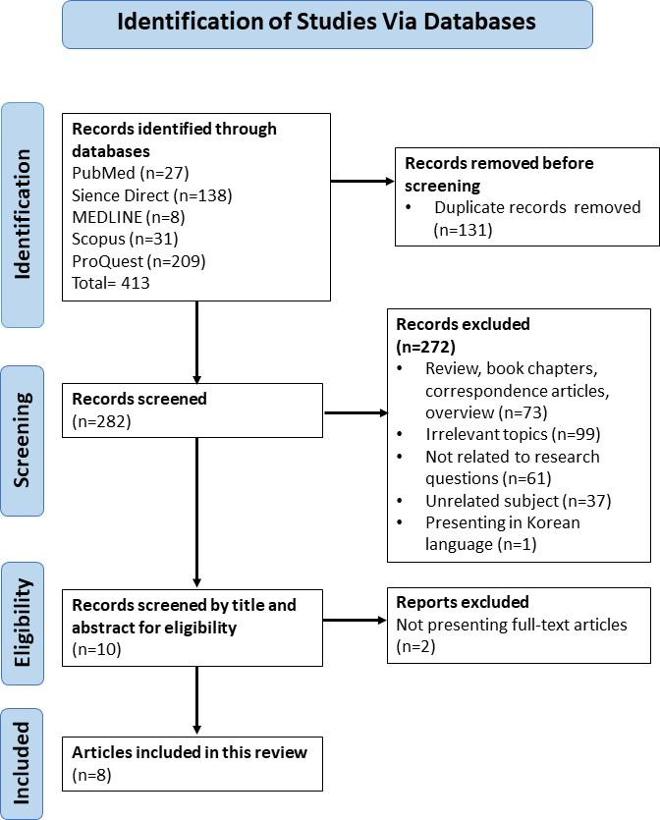
Figure 1: PRISMA flow diagram

RESULTS

Table Style and Format
Tables should be centred or set to autofit the window, refer Tables 1 and 2. Each table must be mentioned or discussed in the corresponding body paragraph and placed directly below the paragraph where it is referenced. The table content should use Calibri font, size 10, aligned to the left.

Captions should be written in sentence case with Calibri font, size 10, using single line spacing, without indentation or additional spacing, and should not end with a full stop. The caption should fit within the width of the table. Authors should arrange tables efficiently within the two-column layout, centring them as shown in Table 1. Larger tables may be set in a one-column layout, as illustrated in Table 3. When switching between two-column and one-column layouts, insert a continuous section break and enable the formatting button to locate the break. Captions should be placed above the tables and should not end with a full stop.

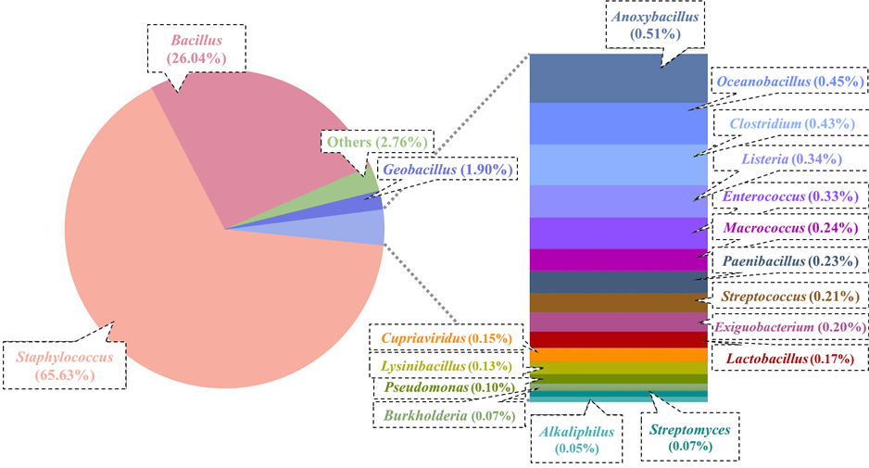
Figure 2: Taxonomic data of the genus rank in the metagenome of a public hospital in Pahang. Staphylococcus and Bacillus made up around 90% of the species in rank genus. Other species listed total up to 5.58% with an average of 0.33% per species, excluding the segment labelled “others”

Table 1: PICOS criteria for inclusion and exclusion of studies (centred)
Category | Inclusion | Exclusion
Participants | Children aged 0–6 years old. | Children with chronic illnesses or special nutritional needs that will impact their dietary diversity.

Table 2: PICOS criteria for inclusion and exclusion of studies (autofit to window)
Category | Inclusion | Exclusion
Participants | Children aged 0–6 years old | Children with chronic illnesses or special nutritional needs that will impact their dietary diversity

Table 3: Instruments and scales used in determining PEB (large table in a one-column layout)
Author (year) | Screening Tools | n (%)
Food responsiveness/ length of time for each meal and eating activities
Hikmah & Nur Islami (2022), Yaqob Qazaryan & Kazim Karim (2019), Chao (2018), Tan et al. (2022), Derks et al (2018), and Shettiwar & Wade (2019) | CEBQ | 6 (75.0)
Emotional overeating
Hikmah & Nur Islami (2022), Yaqob Qazaryan & Kazim Karim (2019), Chao (2018), Tan et al. (2022), Derks et al (2018), and Shettiwar & Wade (2019) | CEBQ | 6 (75.0)
Food preferences/ high selective intake
Hikmah & Nur Islami (2022), Yaqob Qazaryan & Kazim Karim (2019), Chao (2018), Tan et al. (2022), Derks et al (2018), and Shettiwar & Wade (2019) | CEBQ | 7 (87.5)
Chao (2018) | Modified version of UKSQ | 7 (87.5)
Kumar et al. (2018) | SFQ | 7 (87.5)

DISCUSSION

Equation Style and Format
Equation formatting guidelines
All equations referenced in the body paragraph should be cited as Eq. (1), Eq. (2) and so on. Please use Microsoft Word Equation to format equations, with a font size of 11. Each equation should be numbered as follows:

(1)

Sample size, n = [Z _{α/2} / Δ]²p(1-p) (2)
n = [1.96/0.06]² 0.2(1- 0.2)
n = 171+10% non-response rate
n = 188
where, Z _{α/2} = 1.96 (for 95% confidence interval)
Δ = 0.06 (precision)
p = 0.20 (proportion in population)

CONCLUSION
In conclusion part, authors should highlight the finding of their research that respond to the research objective. Example: In this review, we provide insights into the prevalence of picky eaters among young children and its impact on their growth. The evidence gathered from various studies consistently demonstrated that PEB had significantly impacted the growth of young children for all growth indicators.

ACKNOWLEDGEMENT
Acknowledgement is a compulsory section. If the research was not funded by any grant, please state, "This research was not funded by any grant". Example: This research was funded by the Ministry of Higher Education, Malaysia through the Fundamental Research Grant Scheme (FRGS) for Research Acculturation of Early Career Researchers (Project ID: RACER 24-XXX-XXX).

REFERENCES
The reference list should include only works cited in the text that are published or accepted for publication. References must follow the latest APA style, and include DOI numbers where applicable. Each reference should begin with a space added before the new reference, a hanging indent of 0.5 cm and justified.

Example:
Arksey, H. & O’Malley L. (2005). Scoping studies: Towards a methodological framework. International Journal Social Research Methodology, 8:19–32. https://doi.org/10.1080/1364557032000119616 Example for journal bibliography of two authors; In-text citation: (Arksey & O’Malley, 2005).
Baggott, J. E. (1992). The meaning of quantum theory : a guide for students of chemistry and physics. Oxford University Press Example for book bibliography; In-text citation: (Baggott, 1992)
Kwon, K., Shim, J., Kang, M., & Paik, H.-Y. (2017). Association between Picky Eating Behaviors and Nutritional Status in Early Childhood: Performance of a Picky Eating Behavior Questionnaire. Nutrients, 9(5), 463. https://doi.org/10.3390/nu9050463 Example for journal bibliography of more than two authors; In-text citation: (Kwon et al., 2017)
Nalepa, N. (2024). Back to School: What to Pack for Those Picky Eaters. Eyewitness News, August 8, 2024. https://www.wfsb.com/2024/08/08/back-school-what-pack-those-picky-eaters/ Example for newspaper bibliography; In-text citation: (Nalepa, 2024)
Sukri, A., Zaki, H. H. M., & Zin, N. M. (2022). Antibiotic Resistance Patterns of Coagulase-Negative Staphylococcus (CoNS) Isolates from a Major Teaching Hospital in Kuala Lumpur, Malaysia. Sains Malaysiana, 51(3), 865–872. https://doi.org/10.17576/jsm-2022-5103-20
Tricco, A. C., Lillie, E., Zarin, W., O'Brien, K. K., Colquhoun, H., Levac, D., Moher, D., Peters, M. D. J., Horsley, T., Weeks, L., Hempel, S., Akl, E. A., Chang, C., McGowan, J., Stewart, L., Hartling, L, Aldcroft, A., Wilson, M. G., Garritty, C., Lewin, S., Godfrey, C. M., Macdonald, M. T., Langlois, E. V., Soares-Weiser, K., Moriarty, J., Clifford, T., Tunçalp, Ö., & Straus, S. E. (2018). PRISMA Extension for Scoping Reviews (PRISMA-ScR): Checklist and Explanation. Annals of Internal Medicine., 169(7):467-473. https://doi.org/10.7326/M18-0850
World Health Organization (2021, April 12). Indicators for assessing infant and young child feeding practices: definitions and measurement methods. https://www.who.int/publications/i/item/9789240018389 Example for website bibliography; In-text citation: (World Health Organization, 2021)

* Corresponding author. E-mail address: author.mail@gmail.com Journal homepage: https://journals.iium.edu.my/ijahs/index.php/IJAHS EISSN NO 2600-8491

