Journal of Islamic Finance, Vol. XX No. X (2020) 0xx-0xx
IIUM Institute of Islamic Banking and Finance
ISSN 2289-2117 (O) / 2289-2109 (P)
SAMPLE PAPER (TITLE)

First Middle Last (Author 1)ª, First Middle Last (Author 2)^{b*}
First Middle Last (Author 3)^{c}

^{a,b} Dept. Name of Organization (of Affiliation), Name of Organization (of Affiliation), City, Country
^{c} Dept. Name of Organization (of Affiliation), Name of Organization (of Affiliation), City, Country

*Corresponding author: single corresponding author email address
(Received: Day Month Year; Accepted: Day Month Year; Published on-line: Day Month Year)

Abstract

Use the styles provided in this document to write the abstract of your paper. Max abstract 250 words.

Keywords: Abc, Def, Ghi, Jkl, Mno (max 5 keywords)

© IIUM Press

Introduction

Introduction is in this section (first paragraph). Adam et al. (2020) stated on the dynamic of research.
Continue with second paragraph. This is further supported by Smith and Jensen (2018).

- Literature Review

2.1 Sample
Literature review begins here (Faruqi et al., 2016; Smith and Jensen, 2018; Lim and Mohd, 2019; Ahmad and Farooq, 2020).
Literature review continued.

2.2 Sample 1
Literature review begins here.
Literature review continued.

2.3 Sample 2
Literature review begins here.
Literature review continued.

2.4 Sample 3
Literature review begins here.
Literature review continued.

- Conceptual Framework

Conceptual framework begins here.
Conceptual framework continued.
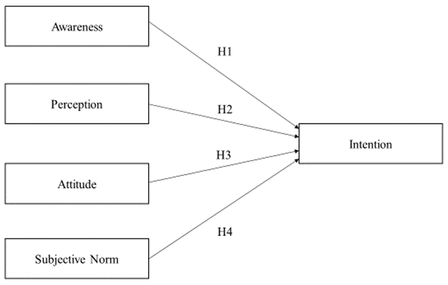

Figure 1: Conceptual Framework

4. Research Methodology

Research methodology is discussed.
Research methodology is continued.

$A=πr^{2}$ (Equation 1)

Table 1: Descriptive Statistics
Variable | Mean | Standard Deviation | Max | Min
A | 1.0 | 0.5 | 2.0 | 0.7
B | 1.1 | 0.6 | 2.2 | 0.8
C | 1.2 | 0.7 | 2.3 | 0.9
D | 1.3 | 0.8 | 2.4 | 1.0

5. Results and Discussion

Results are discussed.
Results are as discussed.

6. Conclusion and Recommendation

Results are discussed.
Results as discussed.

Acknowledgement

This research was funded by the Grant No. 123456/78.

References

Sonko, M. (2020). Customers’ perceptions on Islamic banking: A case study in the Gambia. Journal of Islamic Finance, 9(1), 13–23.

Antova, I., & Tayachi, T. (2020). Managing crypto-pegged exchange rates risks in Islamic banks in the era of digitalization economy and tokenization. Journal of Islamic Finance, 9(1), 13–23.

Ginting, L.M., & Redzuan, N.H. (2020). A study on the influence of Islamic financial literacy in managing cash and debt among millennial in Indonesia. In Kassim, S., Anwar Othman, A.H., & Haron, R. (Eds.). Handbook of research on Islamic social finance and economic recovery after a global health crisis (pp. 1-20). Pennsylvania: IGI Global.

Oseni, U.A., Hassan M.K., & Hassan, R. (2019). Emerging Issues in Islamic finance law and practice in Malaysia. Bingley, UK: Emerald Publishing Limited.

Ismail, A.G., Zaenal, M.H., & Taufiq, U. (2016). Can Islamic philanthropy increase financial inclusion? (IRTI Working Paper 1437-02). Jeddah: Islamic Research and Training Institute.

Gold Banking – A Game Changer for Islamic Finance. (2020). Islamic Finance. Retrieved May 6, 2019, from https://www.islamicfinance.com/2020/08/gold-banking-game-changer-islamic-finance/

