IIUM ENGINEERING JOURNAL
ETHICAL PRINCIPLES AND STANDARDS AGREEMENT FORM

Manuscript ID number: 646

Manuscript Title: LIPS TRACKING IDENTIFICATION OF A CORRECT QURANIC LETTERS‘ PRONUNCIATION FOR TAJWEED TEACHING AND LEARNING

Author(s)–Names, postal addresses and e-mail addresses of all authors:

TAREQ ALTALMAS¹ (eng.tarek87@hotmail.com)
MUHAMMAD AMMAR BIN JAMIL¹ (ammariium@gmail.com)
SALMIAH AHMAD¹ (salmiah@iium.edu.my)
WAHJU SEDIONO¹ (wsediono@iium.edu.my)
MOMOH JIMOH E. SALAMI¹ (momoh@iium.edu.my)
SAMSUL BAHARI MOHD NOOR² (samsul@upm.edu.my)
SURUL SHAHBUDIN HASSAN³ (surur@iium.edu.my)

1Department of Mechatronics in Enginering, International Islamic University Malaysia, Jalan Gombak, 53100 Kuala Lumpur, Malaysia.
2Department of Electrical and Electronic Engineering, Faculty of Engineering, University Putra Malaysia, Serdang, Malaysia
3Centre for Languages and Pre-University Academic Development, International Islamic University Malaysia, Kuala Lumpur, Malaysia

I. Responsibility of Authorship

In accordance with integrity and ethical behaviour in academic works:
a. Onlypersonswhohavesignificantlycontributedtotheresearchorprojectand manuscript preparation shall be listed as coauthors.
b. The corresponding author certifies that anyone named as a coauthor has seen the final version of the manuscript and has agreed to its submission for publication. Deceased authors shall be included, with a footnote reporting date of death.
c. The corresponding author accepts responsibility for having properly included all, and only qualified coauthors.
d. This work has not been published, nor is it currently under consideration for publication elsewhere.

I, the corresponding author, confirm all the above statements to be true.

SALMIAH AHMAD 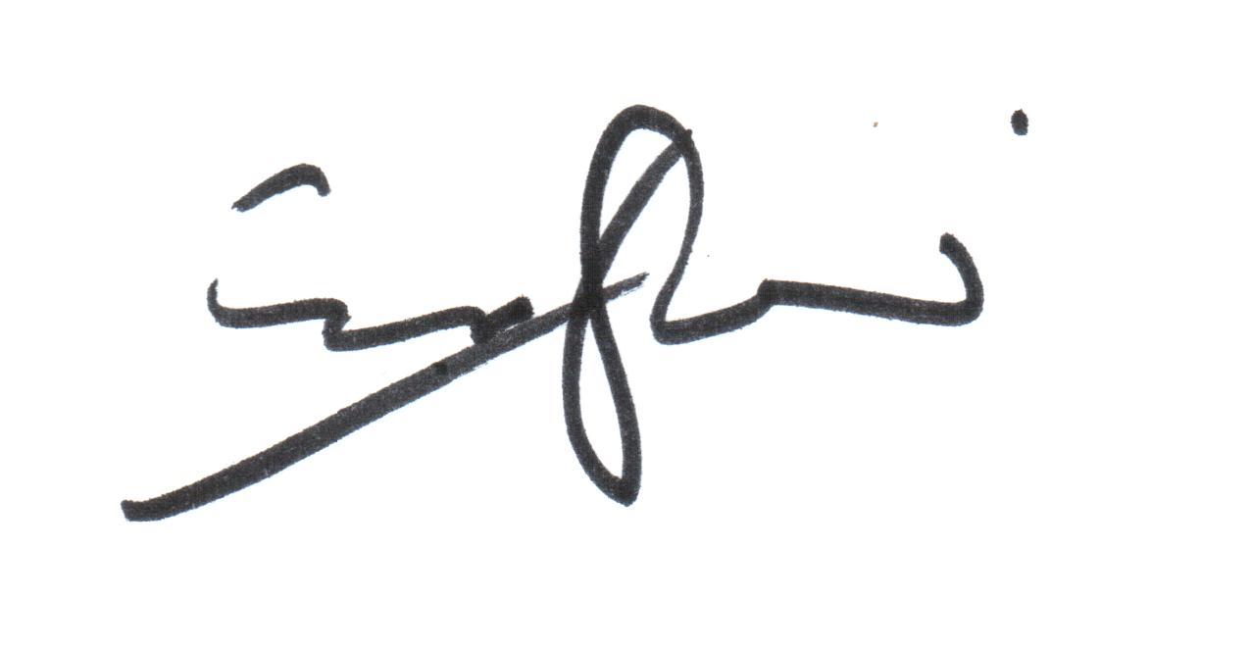 14 March 2016
__________________________________________________________________________________________________
Print Name of corresponding author Signature Date

II. Plagiarism Issues
The manuscript must represent original work by the author(s). None of the material should be covered by any copyright; if copyrighted material exceeding approximately 100 words from a journal article or approximately 500 words from a book is used, the author has obtained written permission for its use. Further, this work should not infringe any intellectual property rights/secrecy laws of any person/organization/government/public or private agency, nor should it contain any defamatory matter.
IIUM Press does not bear any responsibility for verifying copyright permissions provided by the author. Any breach of copyright laws will result in retraction of the published article/material as well as reporting to relevant authorities at the authors’ institutions.
I, the corresponding author, testify that all of the content, figures (drawings, charts, photographs, etc.) and tables in the manuscript are either my/our original work or work for which permission to re-use has been obtained.

SALMIAH AHMAD 14 March 2016

__________________________________________________________________________________________________
Print name of corresponding author Signature Date

