EFFICIENT CAPACITANCE SENSING FOR WIRELESS HEALTH MONITORING SYSTEM
Nurul Arfah Che Mustapha, A. H. M. Zahirul Alam, Sheroz Khan, and Amelia Wong Azman
Dept of ECE, Fac. of Eng., International Islamic Univ. Malaysia (IIUM), Jalan Gombak, 53100 Kuala Lumpur, Malaysia.
n.c.2013@ieee.org,zahirulalam@iium.edu.my, sheroz@iium.edu.my, amy@iium.edu.my
(Received: Day Month Year; Accepted: Day Month Year; Published on-line: Day Month Year)
ABSTRACT: This paper presents a low power capacitance to voltage converter (CVC) circuit using two differential amplifier circuits, two Schottky rectifier diodes constructed in symmetrical manner and combined with instrumentation amplifier circuits. The differential capacitance to voltage simulation work has been realized with cheap discrete components. Combination energy from solar, vibration and heat is expected to be used to source the capacitance circuit. Constant dc voltage of 3 V has been used to source the CVC circuit in this work. It is found by the simulation, the converter circuit consumes 3.9 mW of total power, operates at 40 kHz using 400 mV excitation signal. The circuit is able to detect changes of capacitance from 4 – 12.5 pF using reference capacitance of 5 pF. Sensitivity of 0.132 mV for 1 fF capacitance change has been observed in the circuit. This circuit is suitable for wireless health monitoring system.
ABSTRAK: Kertas kerja ini membentangkan berkenaan litar penukar kapasitor voltan (CVC) berkuasa rendah dengan menggunakan dua litar penguat pembezaan, dua diod Schottky, dibina secara simetri dan digabungkan dengan litar instrumen penguat. Kerja simulasi litar pembezaan kapasitor voltan ini telah dibangunkan dengan menggunakan komponen diskrit murah. Kombinasi tenaga dari solar, getaran dan haba digunakan untuk memberi sumber tenaga kepada litar kapasitor. Voltan DC tetap sebanyak 3 V telah digunakan sebagai sumber tenaga CVC kerja ini. Menerusi simulasi, didapati litar penukaran ini menjana 3.9 mW daripada jumlah tenaga, beroperasi pada kadar 40 kHz dengan menggunakan 400 mV signal pemula. Litar ini mampu mengesan penukaran kapasitan dari 4 – 12.5 pF menggunakan kapasitan rujukan 5 pF. Tahap kepekaan pada 0.132 mV bagi tiap 1 fF perubahan kapasitan telah dikesan menggunakan litar ini. Ia juga sesuai untuk pemantauan sistem kesihatan tanpa wayar.
KEY WORDS: Energy Harvester, Differential Capacitance Sensing, Capacitance Measurement System, Health Monitoring System.
- INTRODUCTION
Recently, the number of appliances that are moving towards wireless communications are on the rise. The wireless data communication approach, though not as reliable as the wired approach, is a preferable choice in many industrial applications where space and accessibility are not always guaranteed. Designers of these appliances began searching for alternatives ways to power their design including opting the use of energy harvesting principle method over conventional wired or battery powered method. One appliance that will benefit the most out of this research is the smart wireless sensor technology.
Smart wireless sensor is an emerging sensor environment with essential features such as on-board micro-processor, sensing capability, wireless communication, battery-less powered system and low-cost maintenance feature. Previously conventional wireless sensor nodes have utilised batteries as the main power supply. Unfortunately, some of the known issues when using batteries occur during replacement of the batteries including loss of valuable time, interruption of services, tedious maintenance job and additional operation cost during maintenance. Therefore, it is crucial and favourable for smart sensor wireless systems to be equipped with self-generated power system for sustainable power supply. The self-generated power sources could come from any of the ambient sources that can be found in an industrial environment such as the vibration, heat, water, human activity and wind.
- BACKGROUND AND MOTIVATION
Capacitive measuring system is an important technology in a transducer system. The motivation behind using capacitive measuring system is that it provides easy as well as efficient conversion of changes in the parameter of interest into a wide range of capacitance changes, which are in turn changed into proportional voltage or frequency changes. The advantage here is that these conversions take place without functionality loss compared to other systems such as the inductive. Such promising solution of powering wireless sensor nodes is by using the source of vibrations, converting mechanical energy to electrical energy. This method has been comprehensively researched over the recent past years. Among the vibrations transducer methods used are piezoelectric, electromagnetic and capacitive-inductive or capacitive-electrostatic approach [1-4]. Each method has its own advantages and disadvantages, but none can currently provide a solution with required power output [5-6]. The selection of converting device is dependent on either capturing or measuring the physical parameters such as displacement, velocity and acceleration.
Many wireless electronic devices such as tiny wireless sensor network nodes, wireless health monitoring systems, as well as consumer products such as smart phone have severely constrained power sources [1, 7]. The main bottleneck in the mentioned devices is largely on the effort to sustain a continuous and reliable power supply without the requirement of batteries, which require to either being charged or to be replaced with a new battery all together at the expense of costs and time. Smart wireless powered sensor has been proven to be cost effective and an alternative solution to this problem when realized properly, particularly in electronic devices used in applications such as in the Structural Health Monitoring (SHM) system, monitoring forest fires, medical implants, and oceans pollution spillages, etc.
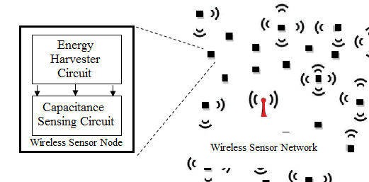
Fig. 1 Topology of the proposed capacitance sensing wireless sensor node.
In this work, a capacitive sensor based circuitry for wireless sensor devices is proposed using hybrid energy harvesting technique as shown in Fig. 1 where the energy generated is expected to be able to operate in wireless frequency range with amount of output power enough for wireless sensor nodes. This work is focusing on deriving energy from vibrations complemented by thermal. Method of generating energy is based on the wireless sensor network characteristic of lowering the respond frequency, maximizing the bandwidth of frequency operation, lowering power consumption and voltage generated.
- STATE OF THE ART
It is important to reduce power requirement whether the power is from energy harvester or from batteries especially for portable devices like computing devices, medical implants, military equipment and wireless sensor network. Most of current researches have focused on microwatt to hundred milli-watt range of power output energy harvesters [4, 8]. The smaller the device size is, the smaller its power requirement becomes. This minimum power requirement shows that it is suitable for modern devices to harvest energy from environment such as from vibrations, heat and light. However, few attempts of research have been made on the medium range power output especially suitable for mobile applications using energy harvester techniques [2]. Efficiency of the power output of energy harvesters is significantly limited by the effectiveness of the energy converting transducers used for energy conversion. Research in [9] has stated that power requirement must be scaled down for size less than 1 cm³ and the power consumption goal should be below than 100 µW. It is necessary for wireless sensor network to be operated in the range of at least 100 µW to 100 mW [10-11].
Portable electronic gadgets such as lightweight mobile smart phone, a capacitive multi-touch screen tablet PC and all-in-one-computers, has been extensively developed over the past years [12-13] with the focus of reducing the battery reliance of such devices has been gaining importance. Such mechanisms are being researched in which energy is harvested from means such as vibration, solar, wind, heat, shoe power, water and oceans. The difference between these techniques lies in the circuit design and its operation principle on which such energy conversion techniques are based on. There are three common techniques used in harvesting energy from vibration, there are: capacitive/electrostatic, piezoelectric and electromagnetic technique. Capacitance inductive/electrostatic harvesting technique is more considered over other techniques because of its ease of implementation in MEMS and CMOS systems.
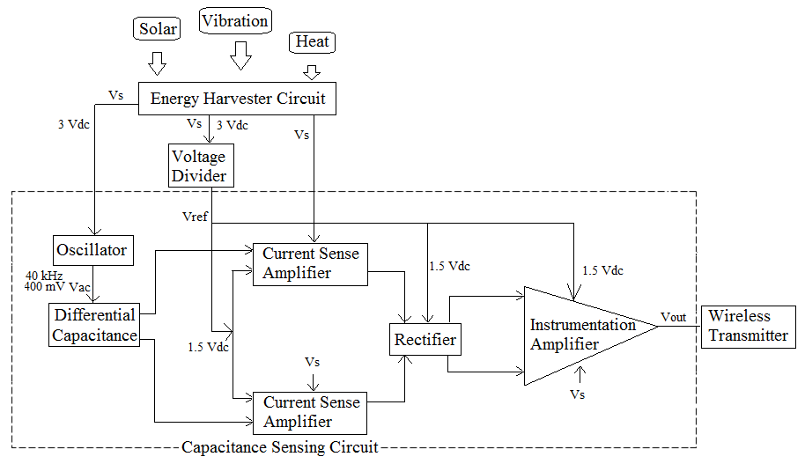
Fig. 2 Block diagram of the proposed capacitance sensing wireless sensor node.
In general, the design of energy harvesting device consist of three main components: a micro-generator, a voltage booster and a storage element [1]. The fact that harvesting device produces very small amount of energy to directly power electronic circuits can become a major drawback faced by circuit designers and researchers [2, 5]. Some efficient and useful technique should be considered to gather and accumulate this energy or to store the converted electrical energy before the harvested energy can be used to power the wireless sensor devices. Research in [14] has highlighted the importance of investigating environmental condition before designing a harvester.
Focus has been made on the energy profiles from the availability of energy from two independent energy sources of thermal and solar. However each harvester has provided a different electrical behaviour level of thermal and solar with 100 mV and few volts respectively which in this case, should supply same level of energy for combination of two power supply. Energy management is required for the combination of both solar cell and thermoelectric transducer to reach high energy yield within a short start-up time where independent voltage booster of available DC/DC converter can be applied to tackle the problem.
Extensive work has been reported [15-19] using capacitance technique where this technique is suitable to be used in wireless application and to source the sensor node. One of the techniques used in MEMS technology is by utilizing the method of capacitive principle. Energy from the environment such as from the vibration is used to move the parallel plate spring mass system, in which it is capable of converting mechanical energy into electrical energy to source the capacitive technique. This capacitive principle requires the charging of the capacitor at all time to ensure the conversion technique. In order to maintain the conversion, these capacitors should be charged with a dedicated electronic switch. However, this technique required additional complex circuitry and relatively high energy losses [15].
Several researchers have highlighted the material of the capacitor plate used. Research in [16] has suggested using soft polymer for sensor device in replacing the battery dependency. A Parylene-electrets generator material has also been reported in [17] where this MEMS-friendly material offers very high surface charge density and has a characteristic of high-aspect-ratio spring.
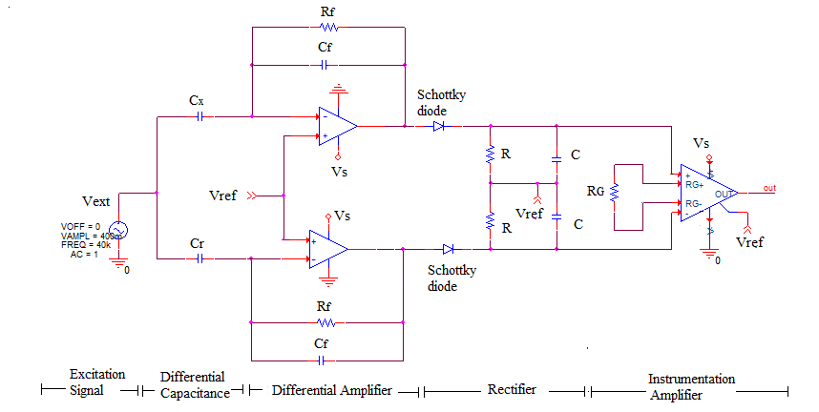
Fig. 3 Capacitance-to-voltage sensing circuit.
Consequently it allows low resonant frequency with large amplitude which is much desired on modern application. However, this electrets technology can cause high costs due to the production and the poling of the dielectric electrets material [18-19]. Electrets have also known for problems regarding long term stability [15]. In order to avoid the problem caused by the electrets, different approach of charging the parallel-plate capacitor has been presented in [20], which is making use of two different materials in its work function. Additional electronic circuitry and MEMS technology is however much simpler than the electrets technique.
- PROPOSED APPROACH
In this work, the capacitance sensor read-out circuit shown in [21] is used for the proposed sensing node architecture in Fig. 2. The different between circuit used in [21] and this work are; (1) PMOS diode is replaced with Schottky diode, (2) voltage divider is used to generate a single source supply from 3 V generated from energy harvester circuit to supply to all reference signal sources, V_{ref}, (3) simulation as in Fig. 3 is done using PSpice simulation tool, based on real components parameters obtained from datasheet such that it can be easily constructed using discrete components available in the market, and (4) lower frequency is used in this simulation, 40 kHz as compared to [21].
- METHODOLOGY
The CVC circuit shown in Fig. 3 has five main blocks, namely the excitation source, differential capacitance, differential amplifiers, rectifier circuit and instrumentation amplifier circuit. The excitation amplitude set in this paper is based from [21]. It is chosen in low range for amplitude, 400 mV and frequency, 40 kHz for later energy harvester’s application. Both feedback, C_{f} and reference capacitance, C_{r} is set fixed at 5 pF. The capacitance detection, C_{x} is varied to the nominal value C_{r} to get accepted linear range, of the changes of capacitance to the output voltage.
In order to reduce the number of signal source, we use voltage divider to source reference voltage, V_{ref} near half of signal source Vs. Figure 4 shows the voltage divider with feedback connected to inverting input amplifier as unity gain buffer amplifier or voltage follower. It consists of pair of resistors connected in series to make a potential divider which feeds divided signal source to the non-inverting input of the opamp. The output voltage of the buffer is connected to the inverting input. Differential between two potentials is applied to the buffer differential input which the output is feed as a reference voltage to the reference input of instrumentation amplifier, the non-inverting input of differential amplifier and rectifier. The unity gain buffer can control the potential difference and stop any unwanted current appeared across the pair resistors.
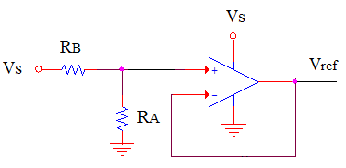
Fig. 4 Voltage divider with unity gain buffer.
According to Thevenin’s law, V_{ref} is approximately half of Vs by using the same value of resistors R_{A} and R_{B}
(1)
The feedback loop of differential amplifier consists of the feedback capacitor, C_{f} in parallel with the resistor, R_{f}. R_{f} is added to reduce presence of small dc offset voltages at the input.
The value is chosen large enough, in this work, R_{f} = 10 MΩ, to overcome the sensitivity to noise problem that exist in the sensor circuit. For an ideal op-amp, the current flowing through the capacitor, is equal to the current flowing through the feedback loop,
The frequency domain analysis is obtained by expression the impedance of the feedback components in the complex plane. The transfer function may be written as
(2)
From Eq. (2) we can derive that V_{out} proportional to the changes of C_{x}+∆C in Eq. (3)

(3)
Having advantage of very low forward voltage drop and ultrafast switching properties, Schottky diode was choose as a rectifier. In this work, we are using 1N711 Schottky diode. It is suitable for very low power and high frequency application. It has a very low reverse leakage current of 200 nA at maximum reverse voltage, V_{r} = 50 V.
According to [21], R and C is chosen to satisfy the range of τ = RC in f_{ext}⁻¹ < τ < f_{s}⁻¹, where f_{ext} is the frequency at common terminal of C_{x} and C_{r} while f_{s} is the frequency at C_{x}. Finally the resistor gain, R_{G} at the instrumentation amplifier is chosen according to R_{G} = 100 kΩ/(G-1) [22]. In this work, we select R_{G} = 100 kΩ to obtain gain, G = 2 from Analog Devices, AD623. All amplifier used in this work is used as a single supply amplifier.
- RESULTS
This work has used the power generated from energy harvester board as its voltage supply of 3 V to power the capacitance sensing circuit. Figure 6 shows the output voltage for different capacitance value from 3.5 pF to 12.5 pF. Capacitance sensing circuit consists of two amplifiers and one instrumentation amplifier with two Schottky rectifier diodes. An excitation supply signal of 400 mV is supplied to the common differential terminal to check for low excitation frequency of 40 kHz.
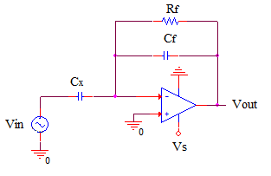
Fig. 5 Differential amplifier circuit with feedback R_{f} and C_{f}.

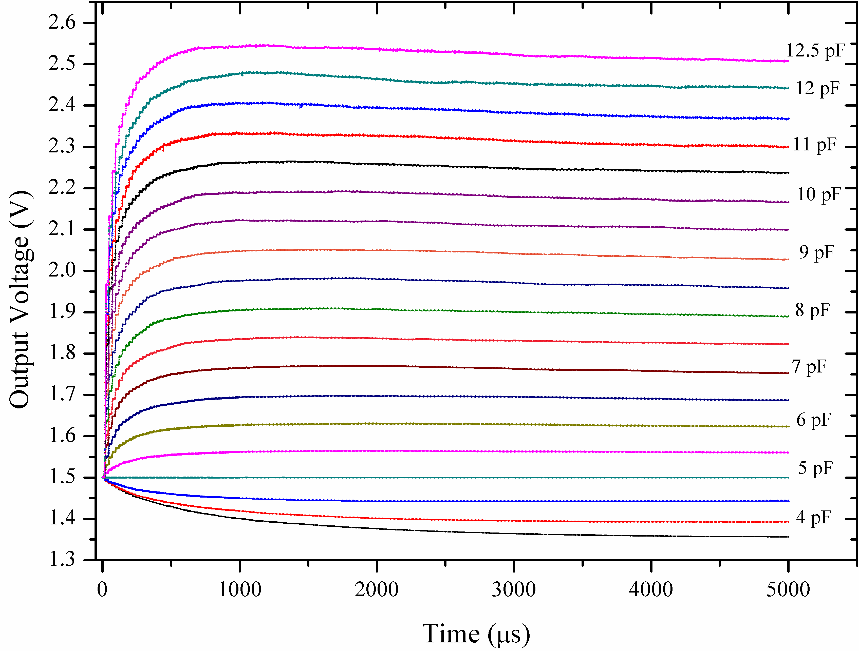
Fig. 6 Voltage output for capacitance value variation at nominal 5 pF.
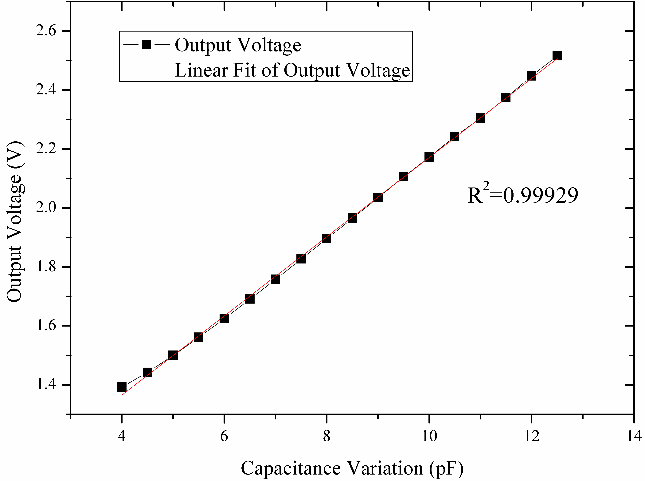
Fig. 7 High linearity performance of DC output circuit result using nominal 5 pF.

Results have shown a high level of linearity output voltage to the capacitance variation as shown in Fig. 7. For nominal 5 pF, the output voltage can be summarized as Eq. (4).
(4)
The output voltage is proportional to the change of capacitance sensing C_{x} in pF range. Comparison of results is listed as in Table 1
Table 1: Comparison of capacitance sensing work.
Ref | C_{SENSE}  [pF] | DC Voltage [V] | P_{diss} [mW] | Sensitivity [mV/fF] | Excitation Signal, Vext
[21] | 4.99 – 5.01 | 1.236 – 1.263 | 5.384 | 1.32 | 400 mV, 400 kHz
This work | 4.00 – 12.5 | 1.392 – 2.516 | 3.900 | 0.132 | 400 mV, 40 kHz
- CONCLUSION
Simulation results on capacitance sensing circuit has shown that the proposed circuit is able to detect capacitance changes from 4 to 12.5 pF capacitance range using 3 V signal supply. The detected voltage is from 1.4 to 2.5 V using 400 mV excitation sources with 40 kHz frequency. The present results have shown the circuit consumed 3.1 mW of power consumption with high level of linearity with R squared value of 0.99929. Similar linear result also valid for other nominal capacitances values (e.g: 1 pF). The simulated circuit has shown high degree of sensitivity of 0.132 mV/fF. In future, we hope to test the device for sending data wirelessly. Elimination of the excitation source can be done by realizing oscillator circuit at the front-end of the CVC circuit in the future.

ACKNOWLEDGEMENT
This work was funded by the Exploratory Research Grant Scheme ERGS-2013 (Ref: IIUM/504/RES/G/14/3/2/ERGS13-021-0054) by Ministry of Higher Education Malaysia through the Research Centre, International Islamic University Malaysia.

REFERENCES
- C. Kompis and S. Aliwell. “Energy harvesting technologies to enable remote and wireless sensing,” Sensors and Instrumentation KTN Report, pp. 1-72, 2008.
- T. Krupenkin. “Method and apparatus for energy harvesting using microfluidics,” USA # 7898096, 2011.
- L. Wang and F. Yuan. “Energy harvesting by magnetostrictive material (msm) for powering wireless sensors in shm”, SPIE Smart Structures and Materials, 2007.
- S. Beeby, M. Tudor, and N. White. “Energy harvesting vibration sources for microsystems applications,” Measurement Science and Technology, vol. 17, no. 12, pp. R175-R195, 2006.
- G. Park, T. Rosing, M. Todd, C. Farrar, and W. Hodgkiss. “Energy Harvesting for Structural Health Monitoring Sensor Networks,” J. Infrastruct. Syst., vol. 14, no. 1, pp. 64-79, 2008.
- H. Kloub, D. Hoffmann, B. Folkmer, and Y. Manoli. “A micro capacitive vibration energy harvester for low power electronics,” PowerMEMS 2009, Washington DC, USA, pp. 165-168, 2009.
- Louisiana Tech University, “Shoe power generator, embedded in the sole of a shoe, harvest energy”,. Science Daily. Retrieved March 24, 2012, from http://www.sciencedaily.com /releases/2010/04/100426113137.htm , 2010.
- T. Krupenkin and J. Taylor. “Reverse electrowetting as a new approach to high-power energy harvesting,” Nature Communications, vol. 2, p. 448, 2011.
- F. Cottone. “Introduction to vibration energy harvesting”, [PowerPoint slides]. Retrieved from http://wwwnipslab.org/files/file/nips%20summer%20school%202011/Cottone%20Introduction%20to%20vibration%20harvesting.pdf , 2011.
- P. Harrop and R. Das. “Energy Harvesting and storage for electronic device 2009-2019”, IDTechEx Report, 2009.
- D. Zhu, S. Beeby, J. Tudor, N. White, and N. Harris. “A novel miniature wind generator for wireless sensing applications”, at IEEE Sensors 2010, pp. 1-4. Retrieved from http://eprints.soton.ac.uk/271682/, 2010.
- S. Sharma. “Estyle buyers’ guide: your prescription to the right tablet”, Electronics for You, vol. 44, no.2, pp. 88, 2012.
- S. Sharma. “Embedded: touch screens what’s the latest?”, Electronics for You, vol. 44, no.2, pp. 88, 2012.
- C. Viehweger, M. Baldauf, T. Keutel, and O. Kanoun. “Hybrid energy harvesting for autonomous sensors in building automation”, 2012 IEEE International Instrumentation and Measurement Technology Conference (I2MTC 2012) Proceedings, pp. 610-613, 2012.
- I. Kuehne, A. Frey, G. Eckstein, U. Schmi, and H. Seidel. “Design and analysis of a capacitive vibration-to-electrical energy converter with built-in voltage”, Solid-State Device Research Conference, vol. 36, pp. 138 – 141, 2006.
- Stevens Institute of Technology Miniature, “Energy harvesting technology could power wireless electronics”, Science Daily. Retrieved March 22, 2012, from http://www.sciencedaily.com /releases/2010/07/100709131308.htm, 2010.
- M. Edamoto, Y. Suzuki, N. Kasagi, K. Kashiwagi, Y. Morizawa, T. Yokoyama, T. Seki, and M. Oba, “Low-resonant-frequency micro electret generator for energy harvesting application”, Proc. IEEE Int. Conf. MEMS 2009, Sorrento, pp. 1059-1062, 2009.
- T. Sterken, K. Baert, R. Puers, G. Borghs, and R. Mertens. “A new power mems component with variable capacitance,” Pan Pacific Microelectronic Symposium 2003, pp. 27-34, 2003.
- J. Arakawa, Y. Suzuki, and N. Kasagi. “Micro seismic power generator using electret polymer film,” The Fourth International Workshop on Micro and Nanotechnology for Power Generation and Energy Conversion Applications 2004, pp. 187-190, 2004.
- I. Kuehne. “Power mems—a capacitive vibration-to-electrical energy converter with built-in voltage”, Sensors and Actuators A: Physical (142)1, 263-269. doi:10.1016/j.sna.2007.02.036, 2008.
- M. R. Haider, M. R. Mahfouz, S. K. Islam, S. A. Eliza, W. Qu, and E. Pritchard. “A low-power capacitance measurement circuit with high resolution and high degree of linearity”, Midwest Symposium on Circuits and Systems, pp. 261–264, 2008.
- Analog Devices. (1997-2008). “AD623: Single-Supply, Rail-to-Rail, Low Cost Instrumentation Amplifier”. [Online]. Available : www.analog.com/media/en/technical-documentation/data-sheets/AD623.pdf [Oct 22, 2015]

BIOGRAPHIES
Nurul Arfah Che Mustapha was born in Kuala Lumpur, Malaysia, in 1984. She received the B.S. degree in electronics-computer and information engineering in 2008 and the M.S. degree in electronics from International Islamic University, Malaysia (IIUM), in 2011. Currently, she is pursuing her Ph.D degree at the same university, IIUM, Kuala Lumpur. Her research work mainly focused on CMOS capacitance sensing, hybrid energy harvesting, boost converter and wireless circuit design using CADENCE PSpice design tool.
Prof. AHM Zahirul Alam received the B.S. and M.S. degrees in electrical and electronic engineering from Bangladesh University of Engineering and Technology (BUET) in 1984 and 1987, respectively. He obtained his Dr. Engg. from Kanazawa University, Japan in 1996. He was a faculty member in BUET from 1985 to 1991 and from 1996 to March 2002. He worked in MIRAI project in Low-k group in Advanced Semiconductor Research Center, Tsukuba, Japan through Japan Science and Technology fellow from April 2002 to October 2003. He is currently Professor of Electrical and Computer Engineering Department, Faculty of Engineering, International Islamic University Malaysia (IIUM). His research interest includes electronic device modeling and fabrication, RF devices and MEMS, Energy harvesting system, antenna and communication devices. Dr. Alam is life fellow of the Institute of Engineers, Bangladesh (IEB) and Bangladesh Computer Society (BCS), a senior member of the Institute of Electrical and Electronics Engineers (IEEE) and a member of the Institute of Electronics, Information and Communication Engineers (IEICE), Japan.
Dr. Sheroz Khan received the B.S. degree in Electrical and Electronic Engineering from the N-W.F.P University of Engineering and Technology (NWFP UET), Peshawar, Pakistan. He obtained M.S. degree in Microelectronic & Computer Engineering in 1990 from the University of Surrey, United Kingdom. He obtained Ph.D. degree in Electrical Engineering in 1994 from University of Strathclyde, United Kingdom. He remained a faculty member within the department of Electrical and Electronic Engineering at the NWFP UET Peshawar until December 1999 until he joined UNITEN as a Principal Lecture in January 2000. He is senior member of the IEEE. His research interests in power electronics, instrumentation and measurement, smart interfaces and biomedical electronics engineering. He has authored two books and over 100 articles in journals and in the IEEE Proceedings.
Dr. Amelia Wong Azman received the B. Eng. Electronics from the University of Southampton, United Kingdom in 2004 and a Ph.D. degree in 2011 from the University of Queensland, Australia. She was a graduate research assistant for the National ICT Australia (NICTA) from 2006-2010 working with a team on smart surveillance project. Currently she is a lecturer in the Electrical and Computer Engineering Department, Faculty of Engineering, International Islamic University Malaysia (IIUM). Her research works are mostly in the area of VLSI design, signal processing and rehabilitation engineering.

