1
4
2
3
5
6
7
12
13
14
S
N
Biogas
45º
8
9
10
11
14
N
S
Biogas
6

(a) (b)
Figure 1: The biogas digester with built-in solar reverse absorber heater: cylindrical plastic methane tank (1), a reverse absorber heater (2), a pyramidal support (3). Thermo insulating material (4), aluminum foil (5), the metallic absorber (6), slurry (7), inlet (8), the outlet (9), tap (10), the partition (11), the horizontal axes, cylindrical reflecting mirror (12), and horizontal glass cover (13), the inclined glass cover (14).

1
2
3
4
5
6

Figure 2: The cylindrical reflecting mirror of solar reverse absorber heater: the plane mirror strips (1), the plastic sheet (2), the cylindrical metallic ground (3), the plane mirror (4), plastic sheet (5) and plane metallic sheet (6).

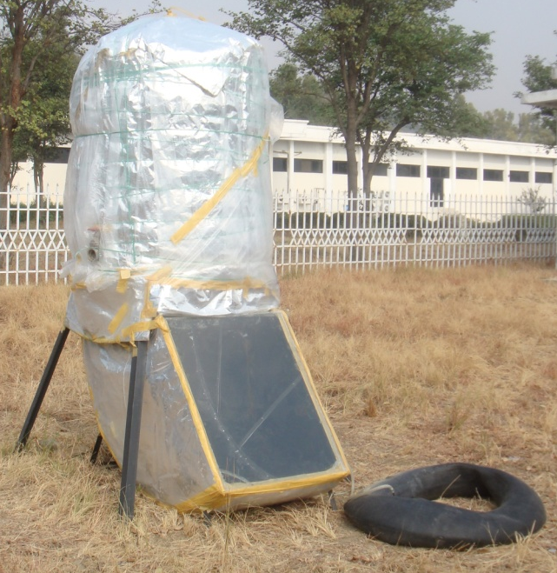
Figure 3: Fabricated solar biogas digester with flexible gas-holder.

- (b)
Figure 4: Solar irradiance-(1, in mW/cm²), ambient temperature (2 in ºC) – and slurry’s temperature (3 in ºC)-time relationships obtained for the one day in October, 2009 (Fig.4-a) and March, 2010 (Fig.4-b).

Solar Biogas Digester
Compressor
10 bar
Gas engine with generator

Compressor
Gas Cylinder
Absorption tower

Water
Compressors
Loads
Upgraded biogas
~90% CH₄
10x10³ kPa pressure
Biogas
Electric power
Water
Absorptiondryer

Figure 5: Removal of carbon dioxide, hydrogen sulphide and water from biogas and conversion of its energy into electric power and compression.

2
1
Water Inlet
Biogas Inlet
4
6
Water Outlet
Upgraded Biogas
8
3
5
7

Figure 6: Schematic diagram of the absorption tower: 1. Tower, 2. Shower for water spray, 3. Metallic plate with pores to hold packing, 4. Pressure Safety Valve, 5. Flanges, 6. Valve, 7. Ceramic Packing Material (Diameter = 25mm), 8.Stand.

Outlet
Inlet
Dry Biogas
Wet Biogas
Silica
Grid
Lid
Column
Support

Figure 7: Schematic diagram of the absorption water dryer.
Table 1. Requirements to remove gaseous components depending on the biogas utilization.
Application | H₂S | CO₂ | H₂O
Gas heater (boiler) | < 1 ppm | No | No
Kitchen stove | Yes | No | No
Stationary engine  (Combined heat and power engine) | < 1 ppm | No | No Consideration
Vehicle fuel | Yes | Recommended | Yes
Natural gas grid | Yes | Yes | Yes

Table 2. Biogas upgrading and utilization in Europe and USA.
Country | Biogas Utilization | Biogas production | CH₄  Reqd (%) | CO₂ Removal technique | H₂S Removal technique | In Operation  since
Czech.Rep. | Vehicle fuel | Sewage sludge | 95 | Water scrubbing | Water scrubbing | 1985
France | Vehicle fuel | Sewage sludge | 96.7 | Water scrubbing | Water scrubbing | 1994
Netherlands | Natural gas | Landfill green waste | 88 | Membranes carbon molecular sieves | Activated Carbon | 1991
Sweden | Vehicle fuel | Sewage sludge vegetable waste | 97 | Water scrubbing  carbon molecular sieves | Water scrubbing  Activated Carbon | 1992
Switzerland | Vehicle fuel, natural gas | Bio waste | 96 | Selexol scrubbing Membranes water scrubbing | Selexol scrubbing Activated Carbon | 1981
USA | Vehicle fuel, natural gas | Landfill Sewage sludge | 98 | Selexol scrubbing Membranes water scrubbing | Selexol scrubbing Activated Carbon | 1981

